|  |
| --- |
| **National University of Computer and Emerging Sciences** |
| In-Lab 6 Exercise  “Stored Procedures and Views” |
|  |
| Database Systems |
| Spring 2024 |

Department of Computer Science

FAST-NU, Lahore, Pakistan

**Total Time: 60 Minutes**

**Schema:**

Schema is given in InLab6OrderCustomerSchema.sql file.

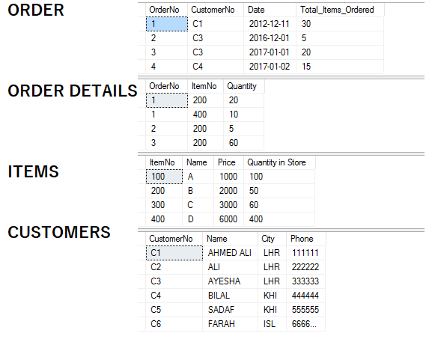

**Exercise for Views:**

1. Create a view that gives order number and total price of that order where total price is equal to item price multiplied by item quantity of that order.
2. Create a view that gives all the items that are doing well in sales. The criteria to judge which item is doing good sale is that the item is has sold more than 20 pieces.
3. Create a view that returns star customers. Star customers are the customers that have made a purchase of more than 2000.
4. Create a view that returns all the customers that have phone number not null WITHOUT WITH CHECK option. Also, create a view with WITH CHECK option. Now, try to insert, delete and update through the view, and observe the results.

**Exercise for Stored Procedures:**

1. Create a stored procedure that takes order number, item number and quantity as input.

If quantity of that item present in store is less than ordered quantity. Print a message ‘Only <quantity in store> is present, which is less than your required quantity.’

If enough quantity is present in store insert the order detail in order details table and subtract the ordered quantity from quantity in store, for that ordered item. Write it’s execute statement as well.

1. You have to create a customer signup stored procedure. It will take all the information of Customer (No, Name City, Phone).

At the end of procedure it should return a flag (as output parameter) that should tell the violation of following rules:

* 1. Rule1: It should check that the customer No should be unique, so if any existing user has same user number it should return the Flag as 1.
  2. Rule 2: City cannot be null, if city is null it should return flag as 2.
  3. Rule 3: Phone number should be of 6 numbers, if it’s less or more it should flag as 3.
  4. If all the above rules are satisfied then customer should be inserted, and flag should be returned as 0.

Write it’s execute statement as well.

1. You have to create a store procedure to cancel an order. It should take customer number and order no as an input, if that customer has placed that order, the order should be deleted and along with that all of its details should also be deleted. If that order number was not placed by that customer, it should print a message ‘Order no <as taken from input> is not of <customerNo><customerName>’. Write it’s execute statement as well.
2. Every customer gets 1 point on purchase of Rs100. Create a procedure that takes customer name as input and return his total points. Write it’s execute statement as well.